Multi-Agent LLM System for 10-K-Based One-Week Stock Prediction
Group 4
By: Gustavo Mercier, Lauren McDonald and Ruitao Zhou

Introduction
Equity research is fundamentally an exercise in information synthesis. Around a single corporate event — the release of an annual 10-K filing — an analyst must reconcile a long regulatory document, structured financial statements, breaking news, and noisy public discussion into one forward-looking judgment, under time pressure and without the benefit of hindsight. Large Language Models (LLMs) are attractive here because they can read and summarize heterogeneous text at scale. A single monolithic LLM, however, tends to inherit the weaknesses of an overstretched generalist: it can anchor on whichever evidence it reads first, blur conflicting signals into a vague consensus, and report unwarranted confidence with no internal check on its own reasoning.
This project addresses those weaknesses with a multi-agent system that decomposes the judgment into specialized roles and then stress-tests the result. Given a company’s most recent 10-K, the system predicts — as of the filing event — whether the stock is a Buy or Not Buy and estimates its target price five trading days later. Three specialized agents work in parallel: a Fundamental agent over the filing and financial statements, a Sentiment agent over news and social discussion, and a Risk agent built as a qualitative–quantitative “coopetition.” A Leader agent aggregates their reports into an initial prediction, and an adversarial Red Team agent challenges it through a bounded rebuttal loop before the system commits to a final answer. Every input is strictly cut off at the filing’s market close to prevent look-ahead leakage. Evaluated as a controlled ablation over the Dow Jones 30, the full system reaches 53.3% directional accuracy with the lowest target-price error, against 36.7% for a single-agent baseline, with the adversarial review and the dual-method risk analysis as the principal drivers of that improvement.

Problem Definition
We frame the task as event-driven, short-horizon forecasting. For each company we anchor on T₀, the moment its 10-K is accepted by SEC EDGAR, and cut every agent-visible input off at the T₀ market close. From that information the system must output (a) a directional label — Buy if the closing price five trading days later (T₀+5) is expected to exceed the T₀ close, Not Buy otherwise — and (b) a point estimate of the T₀+5 target price. The ground-truth label is Buy iff the realized T₀+5 close exceeds the T₀ close, and that realized close is the regression target; it is withheld from every agent and used only for scoring. The study is organized around five research questions:
• RQ1 — Decomposition: does a multi-agent decomposition (fundamental + sentiment + risk + leader) beat a single LLM that sees the same evidence?
• RQ2 — Adversarial review: does the red-team rebuttal loop improve over leader-only aggregation?
• RQ3 — Risk coopetition: does pairing a qualitative and a quantitative risk analyst beat either risk method alone?
• RQ4 — Agent contribution: how much do the sentiment and risk agents add on top of fundamentals alone?
• RQ5 — Robustness: how does performance degrade when data sources are missing?

System Architecture
The system is a five-stage pipeline — data retrieval, parallel specialized analysis, leader aggregation, adversarial review, and final prediction (Figure 1). All retrieved data is consolidated into a shared Data Context that every agent reads, so the agents differ only in role, not in the evidence available to them.
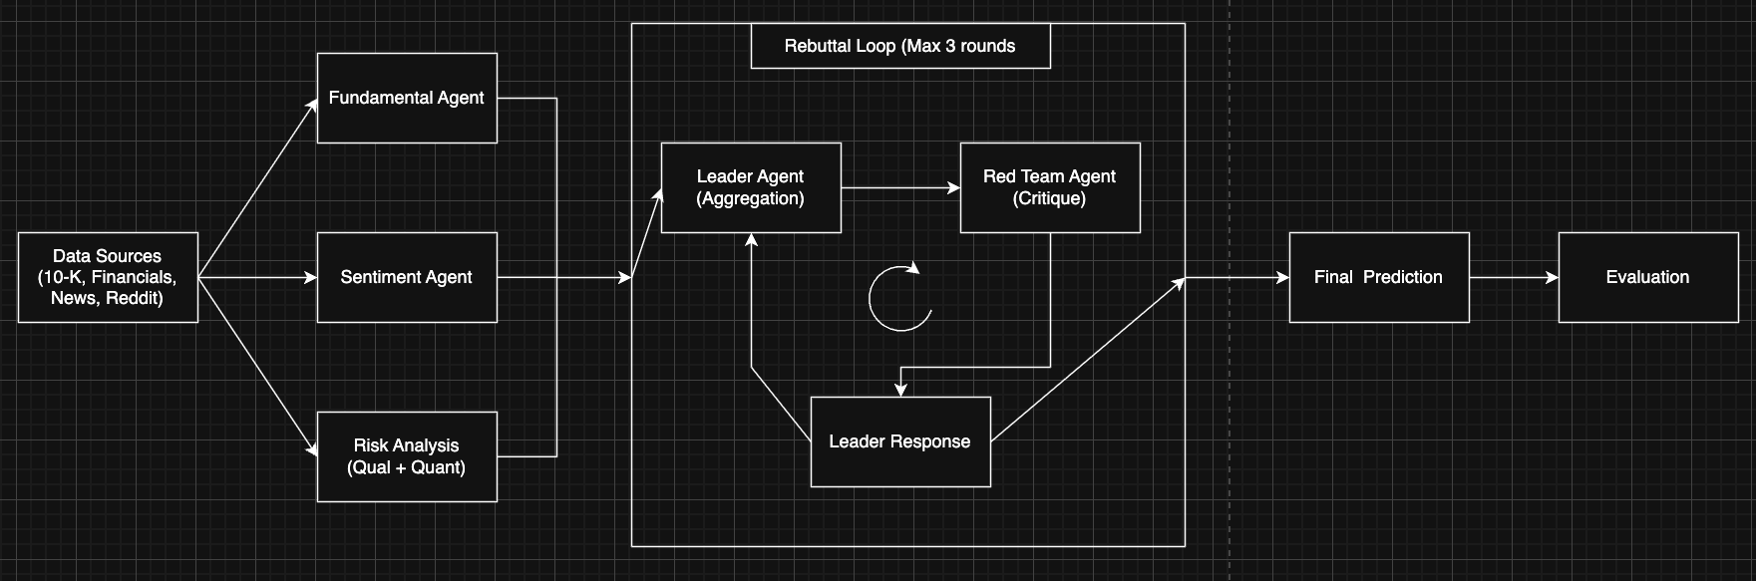
Figure 1. End-to-end multi-agent prediction pipeline.

Specialized Agents
Three agents analyze the company in parallel. The Fundamental agent reads the 10-K and structured financial statements — revenue growth, profitability, cash flow, leverage, valuation, and the management discussion — and returns a structured assessment of financial health. The Sentiment agent reads company news and Reddit discussion to capture market perception that the statements may not yet reflect, returning bullish, bearish, or mixed sentiment with supporting evidence.
The Risk agent is the system’s most distinctive component: a three-phase qualitative–quantitative “coopetition.” In Phase 1 (cooperate) a single facilitator merges the 10-K narrative risks with the financial picture into one de-duplicated list of material risk factors — the shared agenda. In Phase 2 (compete) two analysts score that same agenda independently on a 0–10 scale (10 = highest risk): a qualitative analyst reading only the 10-K (Item 1A risk factors, litigation, competition, regulation, cyber, supply chain) and a quantitative analyst reading only the financials (leverage, liquidity, coverage, margins, valuation) plus the pre-T₀ price trend. In Phase 3 (keep both) the two scores are carried forward un-averaged, forcing the Leader to reconcile any disagreement explicitly rather than hiding it behind an average.

Leader Aggregation and Adversarial Review
The Leader agent consumes the three reports and issues an initial prediction — a Buy/Not Buy label, a target price, a confidence level, and a rationale. An adversarial Red Team agent then critiques that reasoning, probing for missing evidence, logical gaps, overlooked risks, and overconfidence; the Leader responds and may revise. This rebuttal loop repeats until the prediction converges or a three-round cap is reached, improving quality by forcing the system to defend and refine its reasoning.

Orchestration
The workflow is coordinated by LangGraph, which manages a shared PipelineState (retrieved data, agent outputs, prediction and rebuttal history, and the final prediction) and represents the rebuttal loop directly as a cycle in the execution graph. The identical pipeline can also run as plain Python; the two engines are interchangeable and produce equivalent results.

Data
We evaluate on the 30 constituents of the Dow Jones Industrial Average. Each company contributes one prediction instance anchored on its most recent cached 10-K — a balanced large-cap panel that keeps LLM cost tractable while still supporting paired tests across systems. Five sources are unified into the shared Data Context, built once per ticker and reused by every system so all configurations see identical inputs (Figure 2).
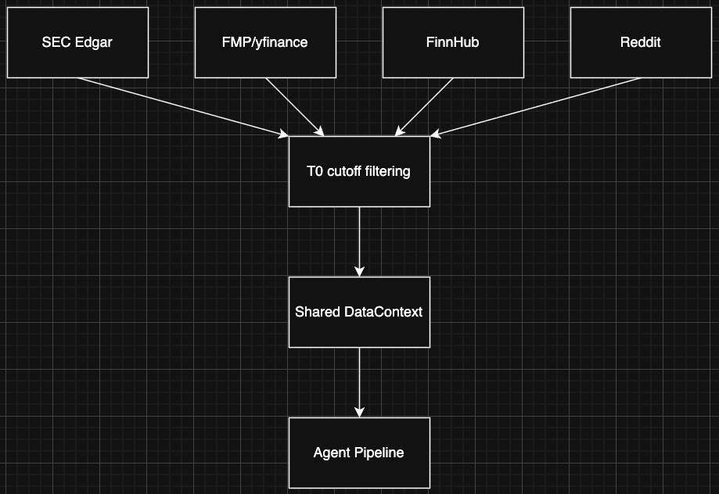
Figure 2. Data retrieval and the shared Data Context.
Source | Provider / tool | Consumed by | Content
10-K filing | SEC EDGAR + RAG (BAAI/bge-small-en-v1.5, 1000-char chunks, 150 overlap, top-k cosine) | Fundamental, Qualitative-risk, Factor-collector | Business, MD&A, Item 1A risk factors (via a search_10k tool)
Structured financials | Financial Modeling Prep (FMP) API | Fundamental, Quantitative-risk, Factor-collector | Profitability, cash flow, leverage, liquidity, coverage, valuation ratios
Company news | FinnHub API | Sentiment | Headlines / articles ≤ T₀ cutoff — FinnHub free tier; returned nothing for 4 of the 30 tickers
Social discussion | Reddit (PRAW) | Sentiment | Retail-investor posts ≤ T₀ cutoff — NOT available in this run (no API key obtained)
Prices | yfinance | Harness (baseline + label, never an agent) | T₀ close (baseline), T₀+5 close (label), pre-T₀ trend (to quant-risk)
Leakage discipline. News and Reddit items are filtered by published_time ≤ the T₀ cutoff, the 10-K and financials are taken as of the filing, and only the pre-T₀ price trend is shared with the quantitative risk agent; the realized T₀+5 price is never exposed to an agent.
Data availability in this run. Two sources were degraded throughout, which the reader should keep in mind. First, we did not obtain a Reddit API key, so the social-post count was zero for all 30 tickers and the Sentiment agent operated on news alone in every run. Second, FinnHub’s free tier returned no articles for four tickers (CRM, HD, NVDA, and WMT), leaving the Sentiment agent with effectively no input for those companies. Third, structured financials from FMP were rejected for 13 of the 30 tickers under the free tier. The harness absorbs all of this through an allow_missing setting: instead of skipping a ticker when an optional source is empty, it degrades that source and records it in a per-ticker missing list (the 10-K and prices remain required). Because financials availability is the only dimension that varies across tickers — Reddit is absent everywhere and news is absent for the same four tickers — the completeness analysis splits on financials alone.

Experimental Setup
Experiments are driven by a single config-based harness. A YAML config names the ticker universe and a list of systems; the harness builds each ticker’s Data Context once, runs every system on it, saves per-cell artifacts (transcript, sub-task reports, leader/red-team exchanges, final prediction, and the answer-key record), and aggregates a wide results table, per-system metrics, and pairwise significance into one directory. Runs are resumable and per-cell failures are logged without aborting the sweep. All results below use the GPT5.4-mini backend with a fixed bootstrap seed (42).
The headline experiment is a six-system ablation, each variant isolating one design choice against the full system:
System | Sub-task agents | Red-team | What it isolates
single | — (one agent sees all evidence) | — | Single-LLM baseline (RQ1)
full | fundamental + sentiment + risk (qual + quant) | up to 3 rounds | The complete multi-agent system
full_no_redteam | fundamental + sentiment + risk | off | Value of adversarial review (RQ2)
risk_qual_only | fundamental + sentiment + qualitative_risk | up to 3 rounds | Value of the quantitative risk half (RQ3)
risk_quant_only | fundamental + sentiment + quantitative_risk | up to 3 rounds | Value of the qualitative risk half (RQ3)
fundamentals_only | fundamental | up to 1 round | Value of sentiment + risk agents (RQ4)

Evaluation Metrics
Because every system is scored on the same tickers, all comparisons are paired:
Metric | Definition | Purpose
Directional accuracy | (1/N) · Σ 1[predicted_dir = actual_dir], with actual_dir = Buy iff price(T₀+5) > price(T₀) | Primary skill measure
Wilson 95% CI | Wilson score interval on the accuracy proportion (z = 1.96) | Honest uncertainty on a 30-ticker panel
Target-price error (APE) | |p_predicted − p_actual| / p_actual, reported as mean and median APE | Calibration of the price estimate
Correlated error rate | Fraction of tickers where all systems are wrong AND predict the same wrong direction | Shared blind spots / lack of diversity
Significance tests | McNemar on paired directions; Wilcoxon signed-rank on paired APE; bootstrap CI on the accuracy gap; Holm–Bonferroni across system pairs | Whether differences are real, not noise
The completeness analyzer recomputes these same metrics within each data-completeness tier, so the robustness question is answered with identical definitions rather than ad-hoc summaries.

Results and Findings
We ran the six-system ablation over all 30 tickers. Every run used the degraded inputs described in the Data section — no Reddit data for any ticker and no FinnHub news for four of them — so the sentiment signal is news-only throughout and effectively absent for those four companies; this should be kept in mind when reading the results. Twenty-nine of thirty tickers completed on every system; one cell (risk_qual_only on MCD) failed to parse the model’s JSON and is excluded, so that system is scored on n = 29. Labels and target prices are scored against the realized T₀+5 close. Per-system accuracy, Wilson confidence intervals, and target-price error are summarized in the text below; the table that follows breaks those numbers down by financials availability, the run’s only varying data dimension.
The full system is the strongest configuration on both axes — the highest directional accuracy (53.3%) and the lowest target-price error (3.18% mean, 2.37% median APE) — while the single-agent baseline is the weakest on price calibration (5.10% mean APE). The ablations map directly onto the research questions:
• RQ1 (decomposition): the full system beats the single-agent baseline by 16.7 accuracy points and roughly halves the median price error. The price-calibration gain is statistically robust — a Wilcoxon signed-rank test on the paired absolute percentage errors rejects equality for single vs. full after Holm–Bonferroni correction (adjusted p = 0.035).
• RQ2 (adversarial review): turning the red-team loop off (full_no_redteam) collapses accuracy from 53.3% back to 36.7% and raises mean APE from 3.18% to 4.12%. The rebuttal loop is the component that lifts the full system above the rest (bootstrap accuracy gap +13.8 points; McNemar p = 0.34, directionally large but not individually significant at this sample size).
• RQ3 (risk coopetition): keeping both risk methods (full, 53.3%) beats either alone — quantitative-only reaches 43.3% and qualitative-only only 31.0%. The quantitative analyst is the stronger single method here, but the two together are best.
• RQ4 (agent contribution): fundamentals_only matches the single baseline on accuracy (36.7%) yet already improves price error (3.98% vs. 5.10% mean APE); adding the sentiment and risk agents plus the red-team loop — i.e. the full system — is what converts that into the 16.7-point accuracy gain.
Statistical significance. With only 30 tickers the directional (McNemar) tests are underpowered: no pair survives Holm–Bonferroni correction on direction (all adjusted p ≈ 1.0). The paired target-price (Wilcoxon) tests are more sensitive and do reject equality, after correction, for the single baseline against full, risk_qual_only, and risk_quant_only (adjusted p = 0.035, 0.034, and 0.002), confirming that the structured systems are better calibrated on price. The correlated error rate across systems is low at 10.3% (3 of 29 shared tickers), so the configurations rarely make the same wrong directional call — evidence that the multi-perspective design produces genuine decision diversity rather than redundant agents.

Robustness to Missing Data (RQ5)
Of the 30 tickers, 17 had structured financials present and 13 had them degraded to empty (on top of the Reddit gap, which affects all 30). Recomputing the metrics within each tier shows that the missing-financials group is markedly harder for every system and is what drags the headline numbers down. Over all 30 tickers the full system leads with 53.3% directional accuracy and the lowest target-price error (3.18% mean, 2.37% median APE), versus 36.7% accuracy and 5.10% mean APE for the single-agent baseline.
System | Financials present (n=17) | Financials missing (n≈13) | Δ
single | 47.1% | 23.1% | −24.0
full | 64.7% | 38.5% | −26.3
full_no_redteam | 47.1% | 23.1% | −24.0
risk_qual_only | 41.2% | 16.7% | −24.5
risk_quant_only | 47.1% | 38.5% | −8.6
fundamentals_only | 41.2% | 30.8% | −10.4
On the financials-present 17-ticker subset the full system reaches 64.7% directional accuracy (vs. 47.1% for the single baseline) and it remains the best system in the degraded tier as well (38.5%). Every configuration loses 8–26 accuracy points when financials are missing, which quantifies the cost of incomplete data. These figures are indicative rather than definitive: they come from a single 30-stock snapshot evaluated with one LLM backend and under the degraded-input conditions noted above, and most pairwise directional differences are not individually significant at this sample size.

Challenges and Future Work
The main engineering challenge was coordinating many independently developed components behind consistent interfaces, which we addressed with a shared contract layer defining common data structures and pipeline state. The main methodological challenge was preventing look-ahead leakage from future news and social media, handled by the strict timestamp filtering described above. Future work includes:
• Larger-scale, multi-date evaluation beyond a single 30-stock snapshot
• Enhanced quantitative risk modeling and additional financial indicators
• Alternative and stronger LLM backends
• Longer prediction horizons

Conclusion
We presented a multi-agent framework that turns an annual 10-K and its surrounding market data into a Buy/Not Buy call and a one-week target price, combining specialized fundamental, sentiment, and qualitative–quantitative risk agents with leader aggregation and adversarial red-team review under LangGraph orchestration. On a Dow-Jones-30 ablation the full system reaches 53.3% directional accuracy with the best price calibration, clearly ahead of a single-agent baseline (36.7%), with adversarial review and dual-method risk analysis as the principal drivers. The results are promising but drawn from a single snapshot and one LLM backend; a larger, multi-date evaluation is the natural next step.

